Salina Central Finishes 2nd in 5A Boys Basketball

The Salina Central boys team concluded a successful season in 2017-18 by finishing 2nd in the 5A state tournament. In a post-season article published by the Salina Journal, the 72 wins in the last four seasons is the best four year stretch since 1970-71. (45 years)

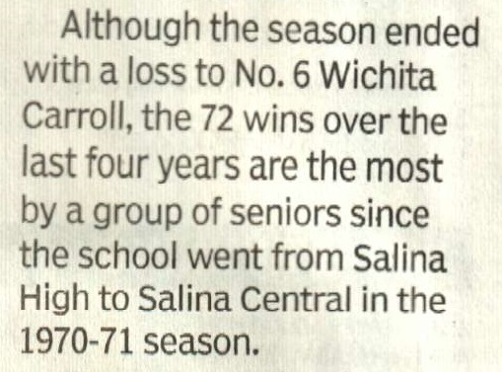

In that same period of time, the MHS boys basketball teams have had 72 or more wins in a four year stretch 33 times.

Metric | Salina Central | McPherson
# of 72 or more Wins in Four Consecutive Seasons  (Since 1970-71) | 1 | 33
Percentage of the 45 Seasons  (Since 1970-71) | 2% (1/45) | 73% (33/45)
# of Times <72 Wins were  realized in a Four Year Stretch  (Since 1970-71) | 44 | 12
# of Years since 72 wins weren't realized in four consecutive seasons | 1 Year  (2014, 2015, 2016, 2017) | 17 Years  (1998,1999,2000, 2001)

Updated: 4/15/2018

McPherson's Four Year Periods in Detail

Four Year Segments | Wins in Each Season | Total Games Won in Segment
2018, 2017, 2016, 2015 | 22, 20, 23, 25 | 90
2017, 2016, 2015, 2014 | 20, 23, 25, 23 | 91
2016, 2015, 2014, 2013 | 23, 25, 23, 19 | 90
2015, 2014, 2013, 2012 | 25, 23, 19, 18 | 85
2014, 2013, 2012, 2011 | 23, 19, 18, 24 | 84
2013, 2012, 2011, 2010 | 19, 18, 24, 22 | 83
2012, 2011, 2010, 2009 | 18, 24, 22, 20 | 84
2011, 2010, 2009, 2008 | 24, 22, 20, 19 | 85
2010, 2009, 2008, 2007 | 22, 20, 19, 23 | 84
2009, 2008, 2007, 2006 | 20, 19, 23, 19 | 81
2008, 2007, 2006, 2005 | 19, 23, 19, 18 | 79
2007, 2006, 2005, 2004 | 23, 19, 18, 21 | 81
2006, 2005, 2004, 2003 | 19, 18, 21, 24 | 82
2005, 2004, 2003, 2002 | 18, 21, 24, 19 | 82
2004, 2003, 2002, 2001 | 21, 24, 19, 12 | 76
2003, 2002, 2001, 2000 | 24,19, 12, 18 | 73
2002, 2001, 2000, 1999 | 19, 12, 18, 24 | 73
2001, 2000, 1999, 1998 | 12, 18, 24, 17 | 71
2000, 1999, 1998, 1997 | 18, 24, 17, 16 | 75
1999, 1998, 1997, 1996 | 24, 17, 16, 24 | 81
1998, 1997, 1996, 1995 | 17, 16, 24, 23 | 80
1997, 1996, 1995, 1994 | 16, 24, 23, 25 | 88
1996, 1995, 1994, 1993 | 24, 23, 25, 21 | 93
1995, 1994, 1993, 1992 | 23, 25, 21, 24 | 93
1994, 1993, 1992, 1991 | 25, 21, 24, 23 | 93
1993, 1992, 1991, 1990 | 21, 24, 23, 24 | 92
1992, 1991, 1990, 1989 | 24, 23, 24, 21 | 92
1991, 1990, 1989, 1988 | 23, 24, 21, 19 | 87
1990, 1989, 1988, 1987 | 24, 21, 19, 13 | 77
1989, 1988, 1987, 1986 | 21, 19, 13, 19 | 72
1988, 1987, 1986, 1985 | 19, 13, 19, 21 | 72
1987, 1986, 1985, 1984 | 13, 19, 21, 17 | 70
1986, 1985, 1984, 1983 | 19, 21, 17, 10 | 67
1985, 1984, 1983, 1982 | 21, 17, 10, 12 | 60
1984, 1983, 1982, 1981 | 17, 10, 12, 8 | 47
1983, 1982, 1981, 1980 | 10, 12, 8, 14 | 44
1982, 1981, 1980, 1979 | 12, 8, 14, 13 | 47
1981, 1980, 1979, 1978 | 8, 14, 13, 10 | 45
1980, 1979, 1978, 1977 | 14, 13, 10, 8 | 45
1979, 1978, 1977, 1976 | 13, 10, 8, 16 | 47
1978, 1977, 1976, 1975 | 10, 8, 16, 18 | 52
1977, 1976, 1975, 1974 | 8, 16, 18, 22 | 64
1976, 1975, 1974, 1973 | 16, 18, 22, 23 | 79
1975, 1974, 1973, 1972 | 18, 22, 23, 16 | 79
1974, 1973, 1972, 1971 | 22, 23, 16, 16 | 77

Shaded lines represent four year periods of less than 72 wins

